**Lesson 2**

**Objectives**

* What is File based approach?
  + Limitations of File based approach
* DBMS approach
  + Advantages of DBMS
  + Cost and Risks Factors.

**What is File base approach?**

An early attempt to computerize the manual filing system.

* Collection of application programs that perform services for the end users (e.g. reports).
* Each program defines and manages its own data.

Assume the Property business; in this business different type of business can be stored. e.g. Sales, Contracts, etc.

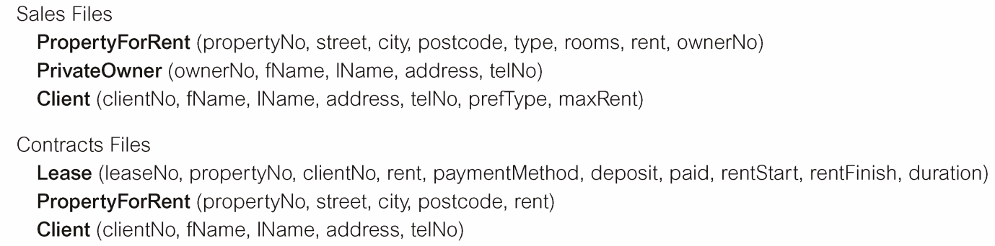

In the above example the data is stored in two files. Each file has different structure; therefore it is difficult to write a single application to perform the user’s operation on created database. Hence, there is a need to write an application for each file with different storage structure. As given below,

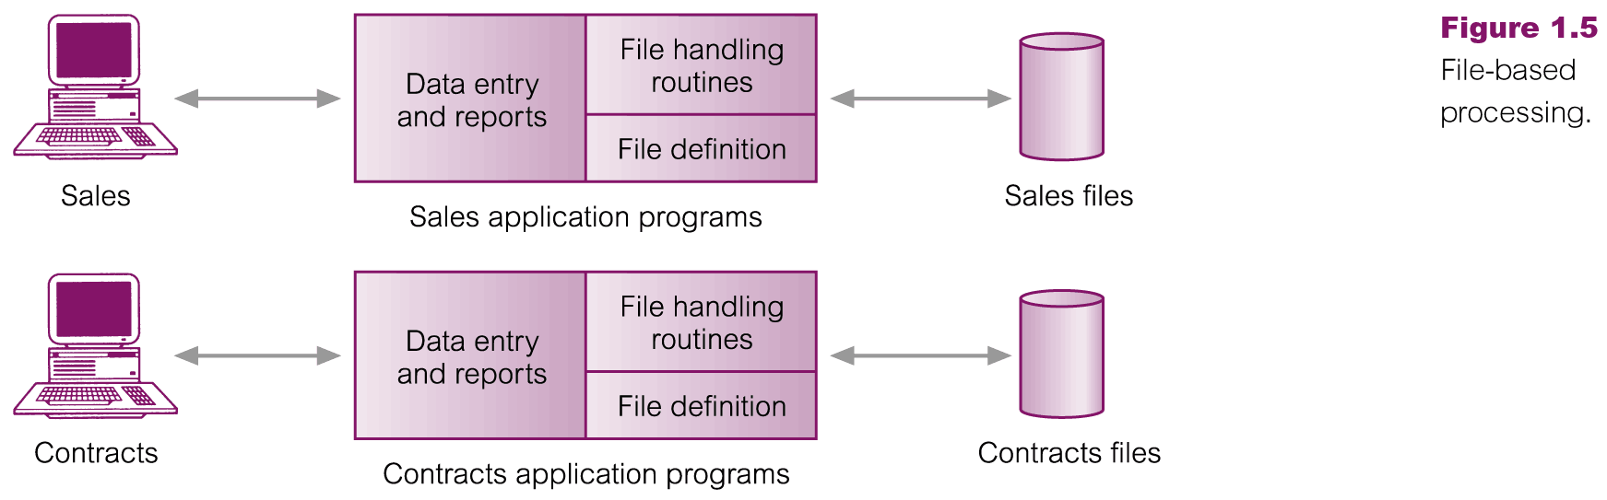

**Limitations of File Based Approach**

* Separation and Isolation of data
  + Data for individual event/department (registration, accounts) is stored separately and treated in isolation.
    - Due to this duplication increased
    - Sharing decreased
    - Development cost increased
* Data dependence
  + File structure is defined in the program code.
* Incompatible file formats
  + Programs are written in different languages, and so cannot easily access each other’s files.
* Fixed Queries/Proliferation of application programs
  + Programs are written to satisfy particular functions.
  + Any new requirement needs a new program.
* Duplication of Data
  + Different systems/programs have separate copies of the same data
  + Waste of space to have duplicate data
  + Causes more maintenance headaches
  + The biggest problem:
    - When data changes in one file, could cause inconsistencies
    - Compromises data integrity
* Limited Data Sharing
  + No centralized control of data
* Lengthy Development Times
  + Programmers must design their own file formats
* Excessive Program Maintenance
  + 80% of of information systems budget

Due to above limitations a need of system rose to overcome these limitations. So a system called database management system (DBMS) proposed to create and manage the database in efficient way.

**Database Management System Approach**

An approach that uses DBMS to create and maintain a database is called database management system approach.

* All user will interact with single application.
* DBMS will tell us how to read ride data from database and provide us controlled access to database.

**Database Management System (**DBMS**)**

A software system that is used to create, maintain and provide controlled access to user over the database is called DBMS.

